**Android App Project (Game)**

Name: Pixel Legacy: The Shiba Saga

(2D Turn-based Battle Game)

Designer: Tszon Tseng

Game Design and Implementation

1. The Splash Screen

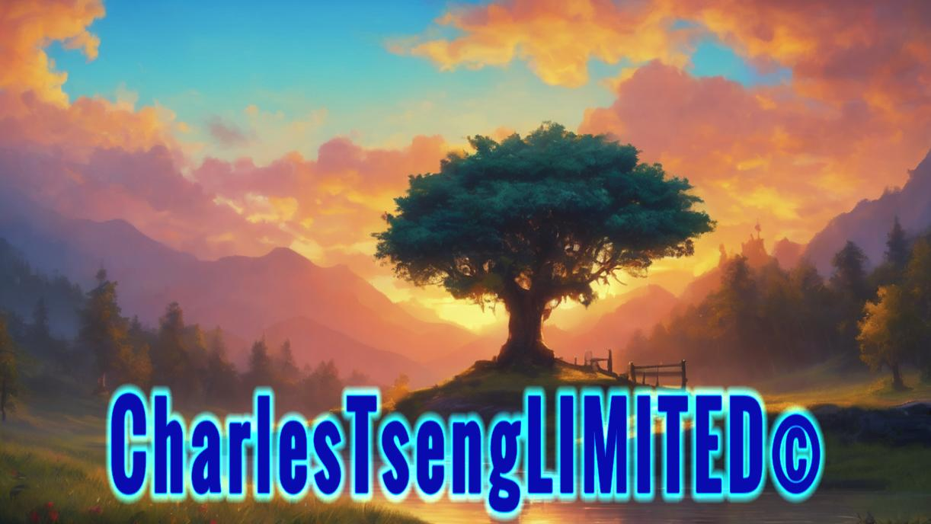

The splash screen is the very first screen to be displayed when the player enters the game, which is usually associated with the brand name and copyright from the developer or company. In my design, I made up a brand using my name to show its originality.

1. The Game Menu Screen

In the game menu screen, a pixel-style user interface is adopted. This title screen is clear and concise, and the design is easily understandable. As the main character of the entire story is our pixelated Shiba Inu, using pixelated font styles suits the theme of the game properly. Additionally, I wish this game would bring some nostalgic memories back to the players of how early-stage RPG games looked like in the 70s and 80s.

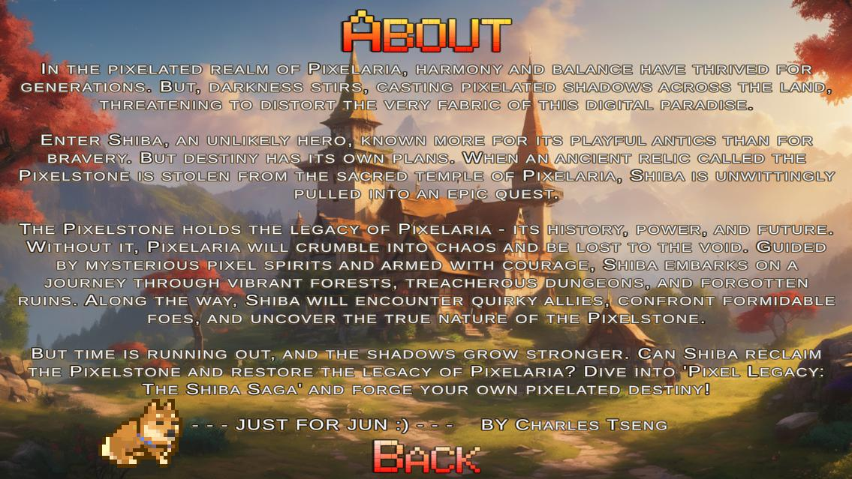The game menu screen consists of three clickable buttons, namely “PLAY”, “ABOUT” and “QUIT”. Once clicked, the “PLAY” button would start the game and lead the player to the Town Scene, while the “ABOUT” button would tell the player a brief story setting of the whole game as depicted above. The player can get back to the previous menu by clicking the “BACK” button. Last but not least, the player can exit and close the game by clicking the “QUIT” button.

1. The Town Scene

This is the Town Scene, where the player would be led upon clicking the “PLAY” button. The player would be guided by a series of dialogues between the main character and other relevant NPCs first. The dialogue system implemented here aims to intrigue the player following closely how the story is going. Once clicked, the “CONTINUE…” button would type out the next line with a sound confirming that the button has been clicked. A relevant portrait of the character is displayed when he is the one having a conversation. As the dialogues go along, the player can feel free to skip the lines by clicking anywhere on the screen when the sentences are not yet typed out completely, smoothing the flow of the overall gameplay experience.

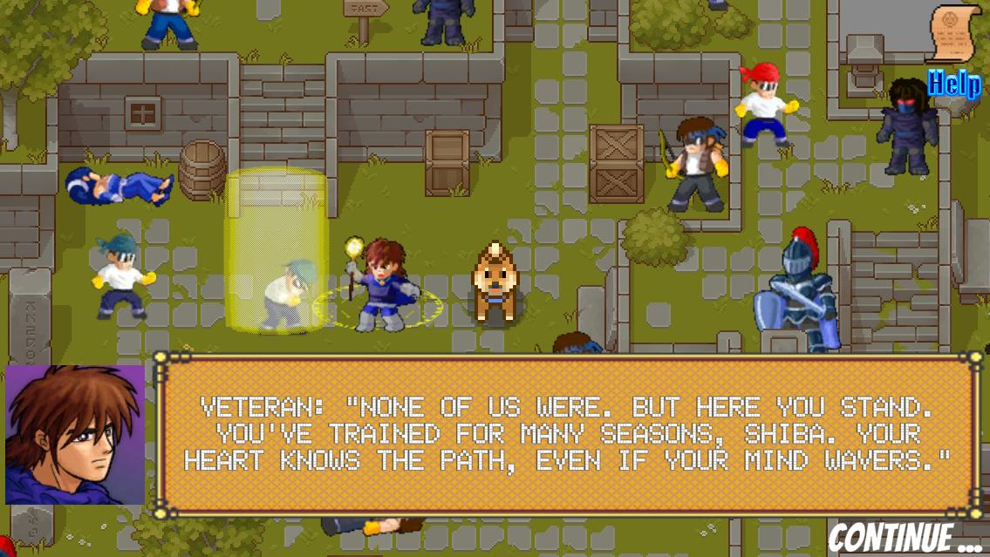Relevant character animations are triggered when certain lines are displayed, making the conversation more interactive and amusing.

Once the dialogues are finished, we can control our pixelated Shiba Inu to move to wherever we want on this map. The NPCs with blue circles are interactable, further conversation about the whole story will be triggered when the player gets close to them. The NPCs with yellow circles, on the other hand, are not interactable when the player collides with them. For the red circle ones, a battle will then be triggered when the player comes close to them.

Further conversation is going on…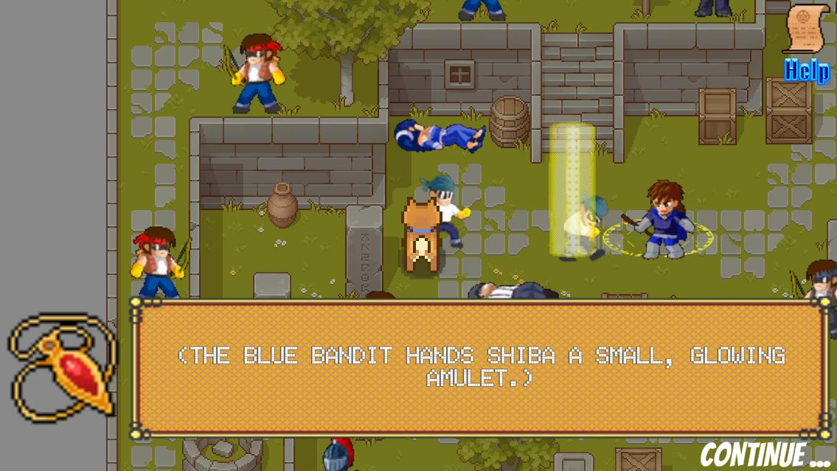The player got an important item from the NPC, which would help push the storyline.

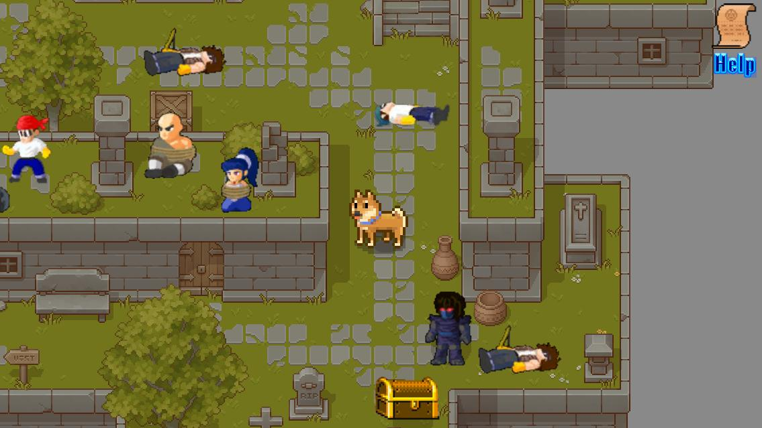

The ones being blue-circled are hostages caught by the enemy, the player needs to figure out ways to rescue them. The grand-looking treasure boxes being red-circled are waiting for the player to be unlocked.

1. The Help Screen Canvas

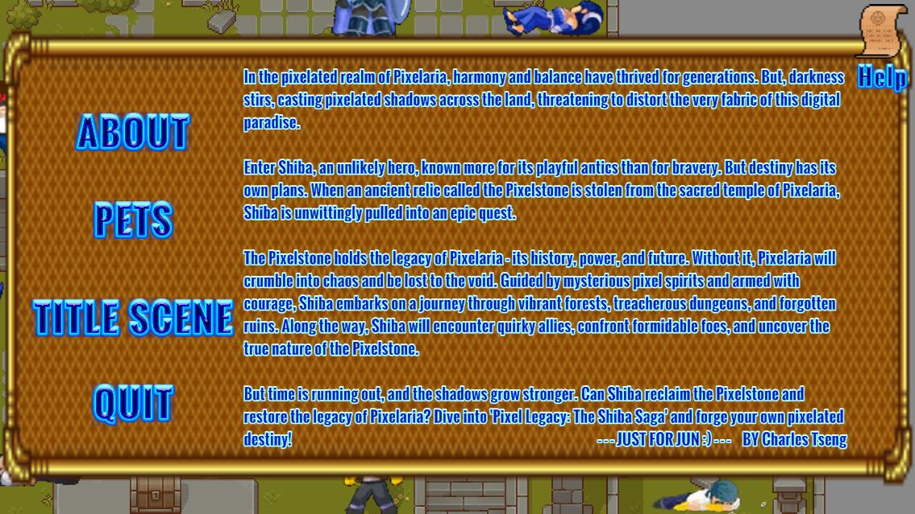Needless to say, the Help Screen Canvas is virtually one of the most crucial elements in all the games, it guides and tells the player what to do when continuing the gameplay. Once clicked, the “Help” icon hovering on the top-right-hand side of the screen will display a Help Screen Canvas. It contains a menu of a total 4 clickable elements, “ABOUT”, “PETS”, “TITLE SCENE” and “QUIT”. The “ABOUT” panel will be displayed as default when the “Help” icon is first clicked.

When the “PETS” icon is clicked, a brief description of each single pet the player currently has will be displayed. The player can go back to the Title Scene or quit the game by clicking the corresponding buttons.

1. The Turn-based Battle Scene

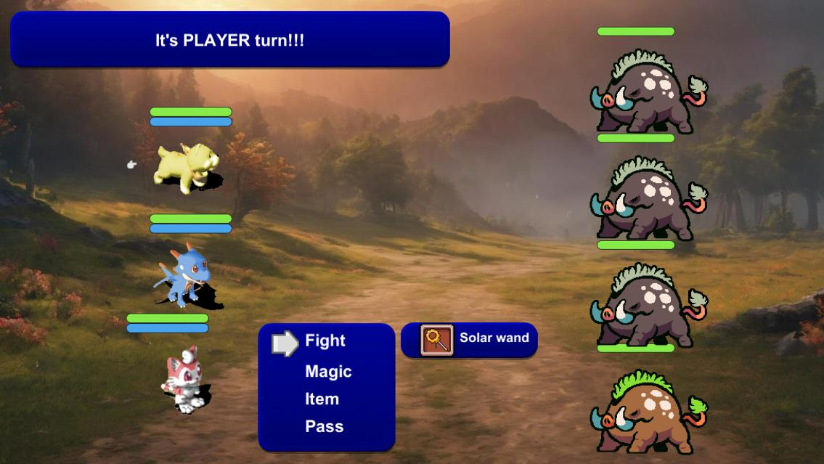Apart from the dialogue system, the turn-based battle mechanism would be another element of utmost importance throughout the entire game. The left-hand side is the player units we got initially from the very beginning of the game as default, and we got random numbers and types of enemies on our right-hand side.

The blue panel in the middle showcases all the possible actions that the player can take, either “Fight”, which is a physical attack costing no Mana, or casting “Magic” spells, where the player can choose whatever spells they like from the list, or consuming “Items”, recovering a certain amount of HP/MP based on the sizes of different portions available. The player might as well even pass without doing anything.

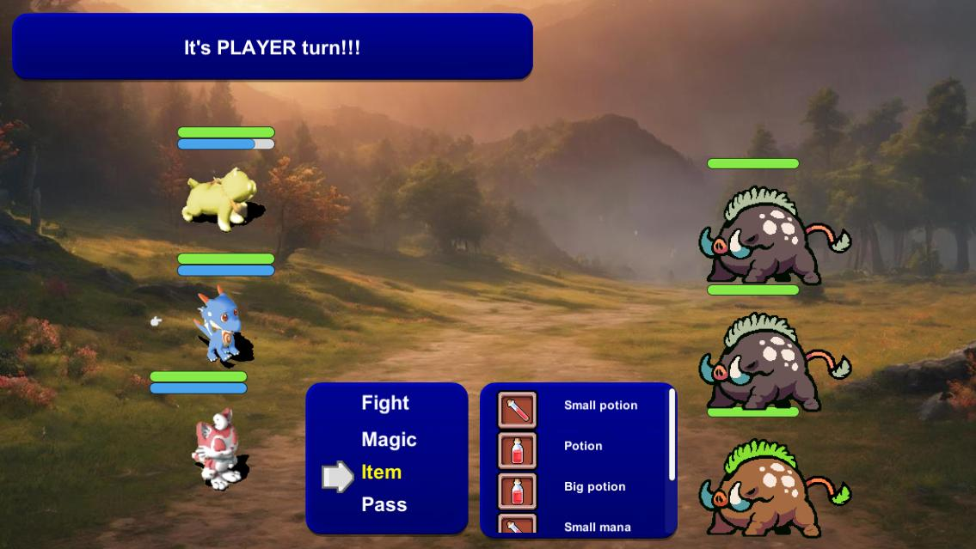

When the battle finishes, winning music is played, and a pop-up message box notifies the player how much EXP they have gotten from the battle. Upon clicking the “OK” button, the player will then be led to the Title Scene. For the time being, I developed just one battle in the entire game.

Problems Encountered

1. **User Interface Scaling:**

Have to design a user interface that scales well on different screen sizes (e.g. tablets and smartphones) and resolutions correspondingly without losing quality or usability.

1. **Legal Concerns:**

In case the game needs to be published to the general public (e.g. Google Play Store), consent should necessarily sought from the sources of the different sprite sheets and maps being used. Ensuring that all game content, including assets and intellectual property, does not infringe on any copyrights or trademarks.

1. **Resource and Time Management:**

I managed to develop at least a complete turn-based battle in my game. If time permits in the future, there will be updates on my project. Managing the project within the constraints of time and budget while still delivering a high-quality product.

Future Improvements

1. **Performance Issues:**

Ensuring the game runs smoothly across a wide range of Android devices with varying hardware capabilities.

Memory leaks or inefficient use of resources can cause slowdowns or crashes.

1. **Asset Management**:

Managing large quantities of game assets (sprites, animations, sound effects, music) can be complex and may require robust asset pipelines in the future if there are any updates to the game.

1. **Data Persistence and Save States**:

A button for saving might be developed in the future when more stages in the game are available. Handling data saving and loading correctly to ensure that player progress is not lost, and game state is consistent.

1. **Localization**:

This game is only currently available in English, languages which suit the taste of the majority may be added in the future (e.g. Traditional/Simplified Chinese, Japanese). Translating the game into different languages and ensuring that cultural nuances are respected can be a complex process.